# 

| Cybersecurity |
| --- |
| Penetration Test Report Template |

MegaCorpOne

Penetration Test Report

**Ninja Security Consultants, LLC**

# 

## Confidentiality Statement

This document contains confidential and privileged information from MegaCorpOne Inc. (henceforth known as MegaCorpOne). The information contained in this document is confidential and may constitute inside or non-public information under international, federal, or state laws. Unauthorized forwarding, printing, copying, distribution, or use of such information is strictly prohibited and may be unlawful. If you are not the intended recipient, be aware that any disclosure, copying, or distribution of this document or its parts is prohibited.

## Table of Contents

Confidentiality Statement 2

Contact Information 4

Document History 4

Introduction 5

Assessment Objective 5

Penetration Testing Methodology 6

Reconnaissance 6

Identification of Vulnerabilities and Services 6

Vulnerability Exploitation 6

Reporting 6

Scope 7

Executive Summary of Findings 8

Grading Methodology 8

Summary of Strengths 9

Summary of Weaknesses 9

Executive Summary Narrative 10

Summary Vulnerability Overview 11

Vulnerability Findings 12

MITRE ATT&CK Navigator Map 13

# 

## Contact Information

| **Company Name** | Ninja Security Consultants, LLC |
| --- | --- |
| **Contact Name** | Christopher Nnaji |
| **Contact Title** | Penetration Tester |
| **Contact Phone** | 555.224.2411 |
| **Contact Email** | Nnaji35@gmail.com |

## Document History

| **Version** | **Date** | **Author(s)** | **Comments** |
| --- | --- | --- | --- |
| 001 | 08/08/2022 | Christopher NNaji |  |
|  |  |  |  |
|  |  |  |  |
|  |  |  |  |

# 

## Introduction

In accordance with MegaCorpOne’s policies, Ninja Security Consultants, LLC (henceforth known as NSC]) conducts external and internal penetration tests of its networks and systems throughout the year. The purpose of this engagement was to assess the networks’ and systems’ security and identify potential security flaws by utilizing industry-accepted testing methodology and best practices. The project was conducted on a number of systems on MegaCorpOne’s network segments by NSC during June of 2021.

For the testing, NSC focused on the following:

* Attempting to determine what system-level vulnerabilities could be discovered and exploited with no prior knowledge of the environment or notification to administrators.
* Attempting to exploit vulnerabilities found and access confidential information that may be stored on systems.
* Documenting and reporting on all findings.

All tests took into consideration the actual business processes implemented by the systems and their potential threats; therefore, the results of this assessment reflect a realistic picture of the actual exposure levels to online hackers. This document contains the results of that assessment.

### Assessment Objective

The primary goal of this assessment was to provide an analysis of security flaws present in MegaCorpOne’s web applications, networks, and systems. This assessment was conducted to identify exploitable vulnerabilities and provide actionable recommendations on how to remediate the vulnerabilities to provide a greater level of security for the environment.

NSC used its proven vulnerability testing methodology to assess all relevant web applications, networks, and systems in scope.

MegaCorpOne has outlined the following objectives:

Table 1: Defined Objectives

| **Objective** |
| --- |
| Find and exfiltrate any sensitive information within the domain. |
| Escalate privileges to domain administrator. |
| Compromise at least two machines. |

# 

## Penetration Testing Methodology

### Reconnaissance

NSC begins assessments by checking for any passive (open source) data that may assist the assessors with their tasks. If internal, the assessment team will perform active recon using tools such as Nmap and Bloodhound.

### Identification of Vulnerabilities and Services

NSC uses custom, private, and public tools such as Metasploit, hashcat, and Nmap to gain perspective of the network security from a hacker’s point of view. These methods provide MegaCorpOne with an understanding of the risks that threaten its information, and also the strengths and weaknesses of the current controls protecting those systems. The results were achieved by mapping the network architecture, identifying hosts and services, enumerating network and system-level vulnerabilities, attempting to discover unexpected hosts within the environment, and eliminating false positives that might have arisen from scanning.

### Vulnerability Exploitation

NSC’s normal process is to both manually test each identified vulnerability and use automated tools to exploit these issues. Exploitation of a vulnerability is defined as any action we perform that gives us unauthorized access to the system or the sensitive data.

### Reporting

Once exploitation is completed and the assessors have completed their objectives, or have done everything possible within the allotted time, the assessment team writes the report, which is the final deliverable to the customer.

# 

## Scope

Prior to any assessment activities, MegaCorpOne and the assessment team will identify targeted systems with a defined range or list of network IP addresses. The assessment team will work directly with the MegaCorpOne POC to determine which network ranges are in-scope for the scheduled assessment.

It is MegaCorpOne’s responsibility to ensure that IP addresses identified as in-scope are actually controlled by MegaCorpOne and are hosted in MegaCorpOne-owned facilities (i.e., are not hosted by an external organization). In-scope and excluded IP addresses and ranges are listed below.

| **IP Address/URL** | **Description** |
| --- | --- |
| 172.16.117.0/16  MCO.local  *.Megacorpone.com | MegaCorpOne internal domain, range and public website |

# 

## Executive Summary of Findings

## 

### Grading Methodology

Each finding was classified according to its severity, reflecting the risk each such vulnerability may pose to the business processes implemented by the application, based on the following criteria:

**Critical**: Immediate threat to key business processes.

**High**: Indirect threat to key business processes/threat to secondary business processes.

**Medium**: Indirect or partial threat to business processes.

**Low**: No direct threat exists; vulnerability may be leveraged with other vulnerabilities.

Informational: No threat; however, it is data that may be used in a future attack.

As the following grid shows, each threat is assessed in terms of both its potential impact on the business and the likelihood of exploitation:

## 

### Summary of Strengths

While the assessment team was successful in finding several vulnerabilities, the team also recognized several strengths within MegaCorpOne’s environment. These positives highlight the effective countermeasures and defenses that successfully prevented, detected, or denied an attack technique or tactic from occurring.

* VPN Login stops the use of burp suite
* open port security windows and linux

### Summary of Weaknesses

NSC successfully found several critical vulnerabilities that should be immediately addressed in order to prevent an adversary from compromising the network. These findings are not specific to a software version but are more general and systemic vulnerabilities.

* Several outdated softwares with vulnerabilities
* linux vulnerabilities
* Windows vulnerabilities

# 

## Executive Summary

Linux Pen Test

During this assessment began by by using shodan, a website that shows ports and possible vulnerabilities.

The next step was to find the vulnerability to exploit and what I’ll need to effectively exploit it. During my attack phase I started with basic password guessing. Passwords are the front gate to your digital infrastructure, and we were able to simply guess a few passwords. After guessing passwords I proceeded with trying to find other credentials that had higher privilege. Using several tools like nmap and zenmap I was able to find open ports and outdated software that I could use to gain access to the system.

Using port 21 we were able to use an exploit found in Metasploit. Using this exploit we were able to to find a document containing admin password and user name

Using these credentials we were able to get to root access, and with root access we have access to the maintain persistence and have continued access to the network. Once here I was able to show view the /etc/shadow file which houses password hashes. After using a program called John the Ripper to decrypt the hashes and have them the corresponding user names.

Persistence is the next step in the test, establishing and consistent backdoor into the network. Once I have root access I added a new user with root access. With that complete I successfully infiltrated the network via linux

Windows Pen Test

During my windows I scanned the same IP address and found several open ports and services that are able to be exploited. I decided to use smb login exploit in Metasploit. Using this plus the credentials from my linux exploit I was able to gain access. I wasn’t able to get RDP access using those credentials so I used a responder to monitor traffic and find credentials to establish a way into the windows system. Once I cracked those hashes using John the Ripper. Once I was able to obtain the new set of credentials, I used Metasploit to use the WMIEXEC command to get info on the system. Using SMBclient I iput a shell.exe file to use to execute remote commands.

Once the shell script is in place I could then begin privilege escalation. Using the new credentials I was able to escalate my shell files privilege to system access. Now that I have escalated privileges I dumped all credentials that are cached and found the proper credentials to use direct access to the RDP system. Once there I move laterally to get the highest windows credentials of other users. In conclusion both linux and windows systems that range from low to critical. Some are system issues and some are simple user issues.

## Summary Vulnerability Overview

| **Vulnerability** | **Severity** |
| --- | --- |
| Weak password on public web application | **Critical** |
| HSTS missing from HTTPS server | **High** |
| Passwords and usernames in text documents. | **Critical** |
| Apache version 2.4 | **Medium** |
|  |  |

The following summary tables represent an overview of the assessment findings for this penetration test:

| **Scan Type** | **Total** |
| --- | --- |
| Hosts | What hosts did you scan? |
| Ports | What ports did you scan? |

| **Exploitation Risk** | **Total** |
| --- | --- |
| **Critical** | 2 |
| **High** | 1 |
| **Medium** | 1 |
| **Low** | - |

## Vulnerability Findings

### Weak Password on Public Web Application

**Risk Rating**: **Critical**

**Description**:

The site **vpn.megacorpone.com** is used to host the Cisco AnyConnect configuration file for MegaCorpOne. This site is secured with basic authentication but is susceptible to a dictionary attack. NSC] was able to use a username gathered from OSINT in combination with a wordlist in order to guess the user’s password and access the configuration file.

**Affected Hosts**: vpn.megacorpone.com

**Remediation**:

* Set up two-factor authentication instead of basic authentication to prevent dictionary attacks from being successful.
* Require a strong password complexity that requires passwords to be over 12 characters long, upper+lower case, & include a special character.
* Reset the user **thudson**’s password.

### Unpatched software on website

**Risk Rating**:High

**Description**:

The site **megacorpone.com** is missing HSTS from the HTTPS. The remote web server is not enforcing HSTS as defined by RFC 6797. HSTS is an optional response header that can be configured on the server to instruct the browser to only communicate via HTTPS.

**Affected Hosts**:megacorpone.com

**Remediation**: Configure the remote webserver to use HSTS

## MITRE ATT&CK Navigator Map

The following completed MITRE ATT&CK navigator map shows all of the techniques and tactics that NSC used throughout the assessment.

Legend:

Performed successfully

Failure to perform

[MITRE ATT&CK navi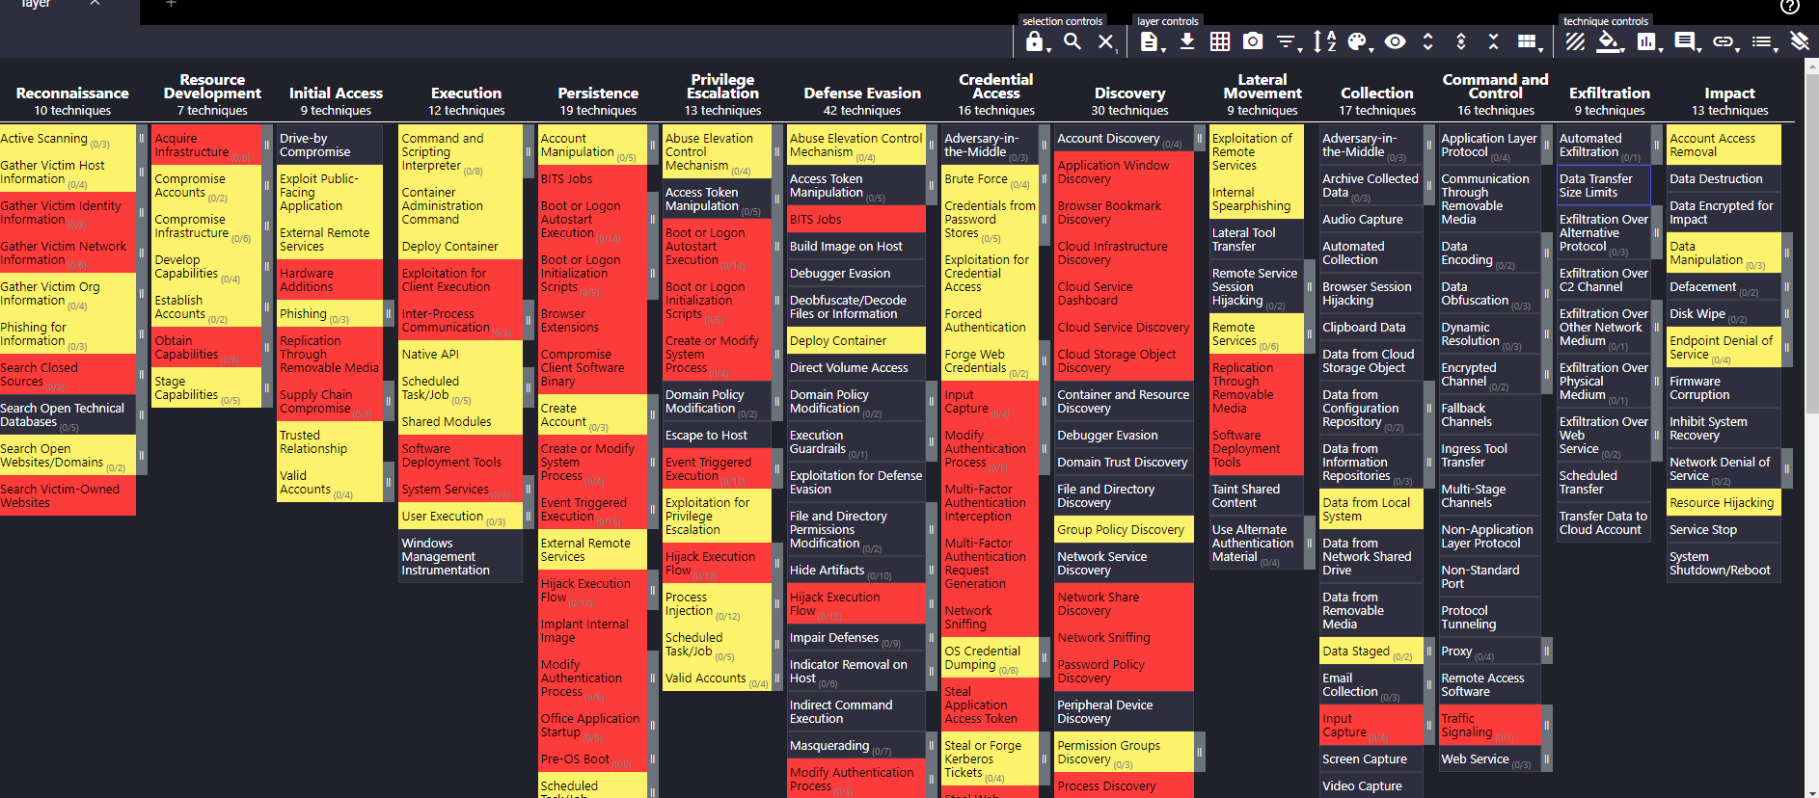gator map]